Date | 30/10/2025
Time id | NM2025TMID06951
Project name | Laptop Request Catalog Items
Maximum mark | 2 marks

Customer Problem Statement Template:

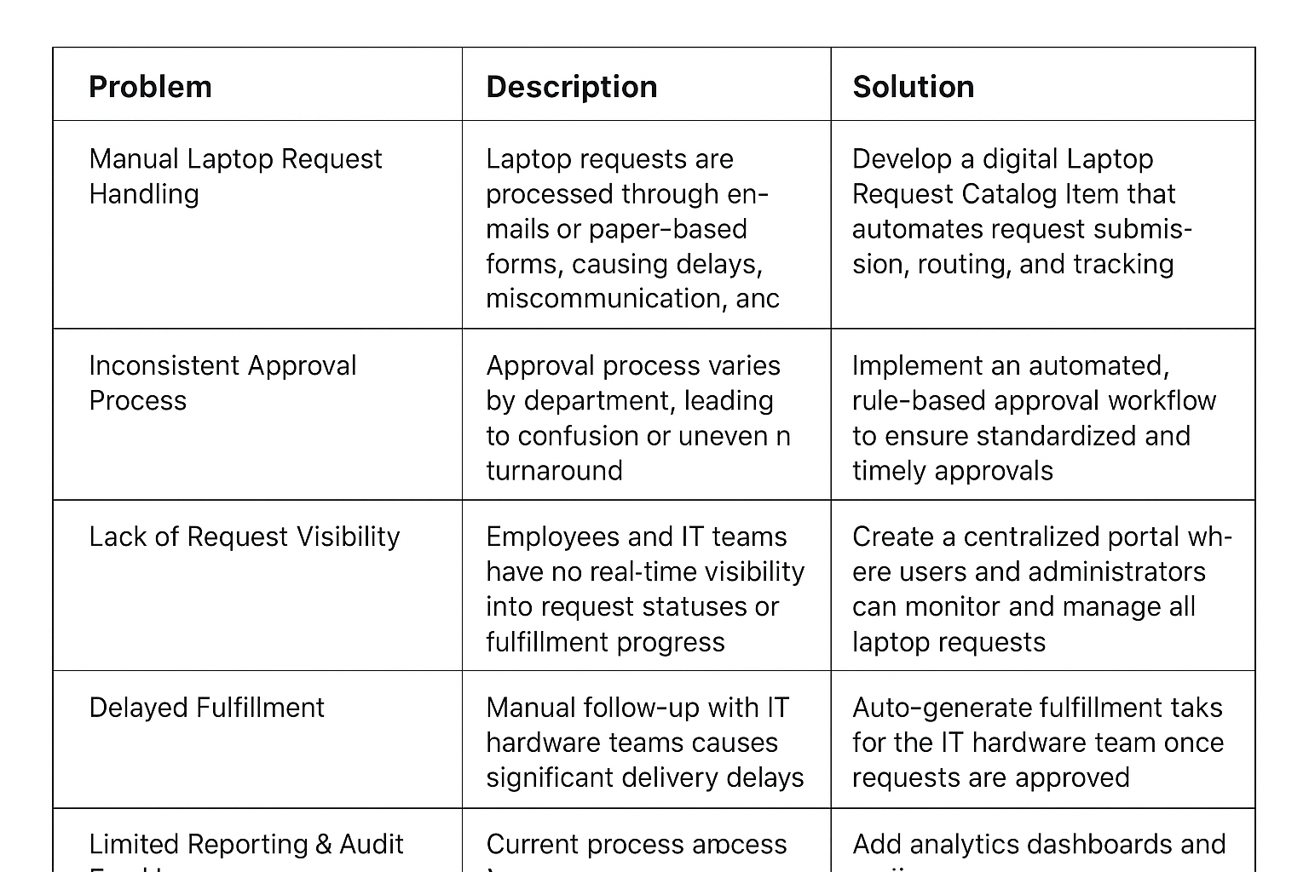

Organizations often face challenges in managing laptop requests due to manual processes, inconsistent approvals, and a lack of real-time visibility into request statuses. Employees must rely on emails or paper forms, causing delays, miscommunication, and errors in asset allocation. IT teams struggle to track requests efficiently and ensure fairness and compliance in laptop distribution. A digital Laptop Request Catalog Item can streamline the process by allowing employees to submit standardized requests, automatically route approvals, and integrate with inventory systems for real-time stock validation. This will reduce manual effort, improve transparency, and enhance the overall IT service experience within the organization.

PROBLEM STATEMENT:
Problem | Description
  Solution
Manual Ticket Assignment | Tickets are currently assigned manually, causing delays and errors in task allocation. | Implement an automated routing system that assigns tickets based on predefined rules and real-time data.
Uneven Workload Distribution | Some agents are overloaded while others remain underutilized, reducing overall efficiency. | Introduce a workload-balancing algorithm to distribute tickets evenly among available agents.
Lack of Skill-Based Routing | Tickets are not always assigned to agents with the right expertise, leading to reassignments and slower resolution. | Create a skill-matching mechanism that maps ticket categories to agent competencies.
Delayed Response Times | Manual sorting and prioritization result in longer ticket queues and slower service delivery. | Use AI or rule-based prioritization to route urgent tickets faster and optimize response times.
Limited Visibility & Tracking | Team leads lack visibility into real-time ticket flow and agent performance | Develop a live dashboard to monitor ticket distribution, status, and performance metrics.

